Herzlia Highlands

Advanced Programme Mathematics

Grade 12

Prelims 2014

Notes

- Calculators in radian mode.
- Calculators in RADIAN MODE.
- NB: Each section must be in a separate workbook!.
- Following on from the last point, there are 3 hours to complete 300 marks.
- Section A contains 15 questions worth a total of 200 marks
- Section B contains 8 questions worth a total of 100 marks.
- Unless otherwise stated, answers to be given to 2 decimal places.
- You should have 3 pages of formulae plus a Normal Distribution table. These are the IEB formulae sheets you will get at the end of the year, so if the formula you are looking for is not here, either you should know this formula, or you are looking for the wrong one!

Section A: Algebra and Calculus (200)

- Find the following limits, if they exist:
  - $\underset{x→6}{\text{lim}}\frac{\sqrt{4x+1}−\sqrt{3x+7}}{x−6}$ (7)
  - $\underset{θ→\frac{π}{4}}{\text{lim}}\frac{\text{cos}2θ}{\text{cos}θ−\text{sin}θ}$ (5)
[12]
- Given the Binomial Theorem: $(a+b)^{n}=\sum_{r=0}^{n}{\begin{aligned}\left(n | \right) \\ \end{aligned}}$,
  - Find the coefficient of $x^{3}\text{ and }x$in the expansion of
${\left(2x−\frac{3}{x}\right)}^{5}$. (6)
  - Hence determine the coefficient of $x$in the expansion of
$\left(1+\frac{2}{x^{2}}\right){\left(2x−\frac{3}{x}\right)}^{5}$ (3)
[9]

- Solve for $x∈C$ given that $x=1−2i$ is a root of
$f(x)=x^{5}−7x^{4}+\text{24}x^{3}−\text{48}x^{2}+\text{55}x−\text{25}$. [14]

- 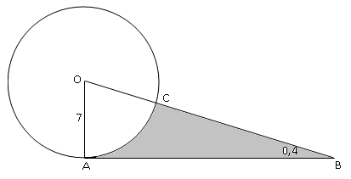
AB is a tangent to the circle centre O. radians. OA = 7 cm.
  - Write down the size of . (2)
  - Find the area of the shaded region. (9)
[11]
- The following equation relates the population of a certain small village near a proposed Russian nuclear testing facility in the Karoo, to be paid for by Eskom, to the time in years from Jan 1, 2014:
$t=\text{100}\text{ln}\left(\frac{4}{3}−\frac{P}{\text{60000}}\right)$
  - Determine the population on Jan 1, 2014. (4)
  - When is the last stubborn resident (and all his mutations) expected to leave the village? Give your answer in date and time to the nearest minute. (5)
  - Show that $P=\text{60000}\left(\frac{4}{3}−e^{\frac{t}{\text{100}}}\right)$ (3)
  - Hence determine the rate at which the population was initially decreasing. (A mark is allocated for the correct units of this answer). (5)
[17]
- Given $f(x)=2\left|x+3\right|−4$, and $g(x)=\left|\frac{4}{x}\right|$.
  - On the same system of axes, draw neat sketch graphs of f and g. (8)
  - Determine the x-coordinate of the point(s) of intersection. (8)
[16]

- Find the equation of the tangent to the curve $−2x^{2}y+2{\text{xy}}^{2}−5x−3y^{3}=\text{12}$ at the point (3 ; -1)
[10]
- Given the general complex number $z=a+\text{bi}$.
  - Write down $\overline{z}$, the complex conjugate of z (1)
  - Determine ${\left|z\right|}^{2}\text{ if }{\left|z\right|}^{2}=z⋅\overline{z}$. (2)
  - Show that $\frac{1}{z}=\frac{\overline{z}}{{\left|z\right|}^{2}}$ (2)
  - Hence determine $z^{−1}$ if $z=3−5i$.
Give your answer in the form a + bi. (4)
[9]

- De Moivre’s Theorem states that
$(\text{cos}θ+i\text{sin}θ)^{n}=\text{cos}(nθ)+i\text{sin}(nθ)\text{ ; }∀n∈Z$
(You may NOT use Euler’s identity at all in this question, which states that
$e^{iθ}=\text{cos}θ+i\text{sin}θ$ , you are, on the other hand, most welcome to use all normal trig identities, which can be found on your formula sheets.)
  - The theorem is clearly true for n = 0 and 1. Show that is also true for
n = 2. (5)
  - Now show the inductive step that, together with 9.1, allows you to state that De Moivre’s is at least true for $∀n∈N$. (Hint: $x^{p+1}=x⋅x^{p}$). (8)
  - Now use your result in 8.3 together with the exponent law $x^{−p}=(x^{p})^{−1}$ to extend your conclusion from 9.2 to include all negative integers. (6)
[19]
- Determine the area of the shaded region. [10]

- Starting with a circular piece of paper, with fixed radius R, and major arc ABC which subtends angle θ at centre O. AO and CO are now joined to form a canonical cup with circular top of radius r and height h.
  - Write down the length of major arc ABC in terms of R and θ. (1)
  - Show that $r=\frac{Rθ}{2π}$ (3)
  - Given that the volume of a cone radius r, height h is $\frac{1}{3}π\text{.}r^{2}h$
Show that the volume of the cup is:
$V=\frac{R^{3}θ^{2}}{\text{24}π^{2}}\sqrt{4π^{2}−θ^{2}}$ (5)
  - Hence, find the value of θ for maximum volume (9)
[18]

- Given $g(x)=\frac{x^{2}+6}{x^{2}+x−6}$
  - Determine the intercepts with the axes. (2)
  - Show that g has a horizontal asymptote at y = 1. (2)
  - Determine the equation(s) of all other asymptotes (2)
  - Determine and classify all turning points of g (10)
  - State the domain of g and determine g’s limits at the edge of its
domain. (5)
  - Draw a neat sketch of the graph, indicating all relevant points, including the coordinates of the point of intersection between g and its horizontal asymptote.
SHOW ALL WORKING please. (6)
[27]
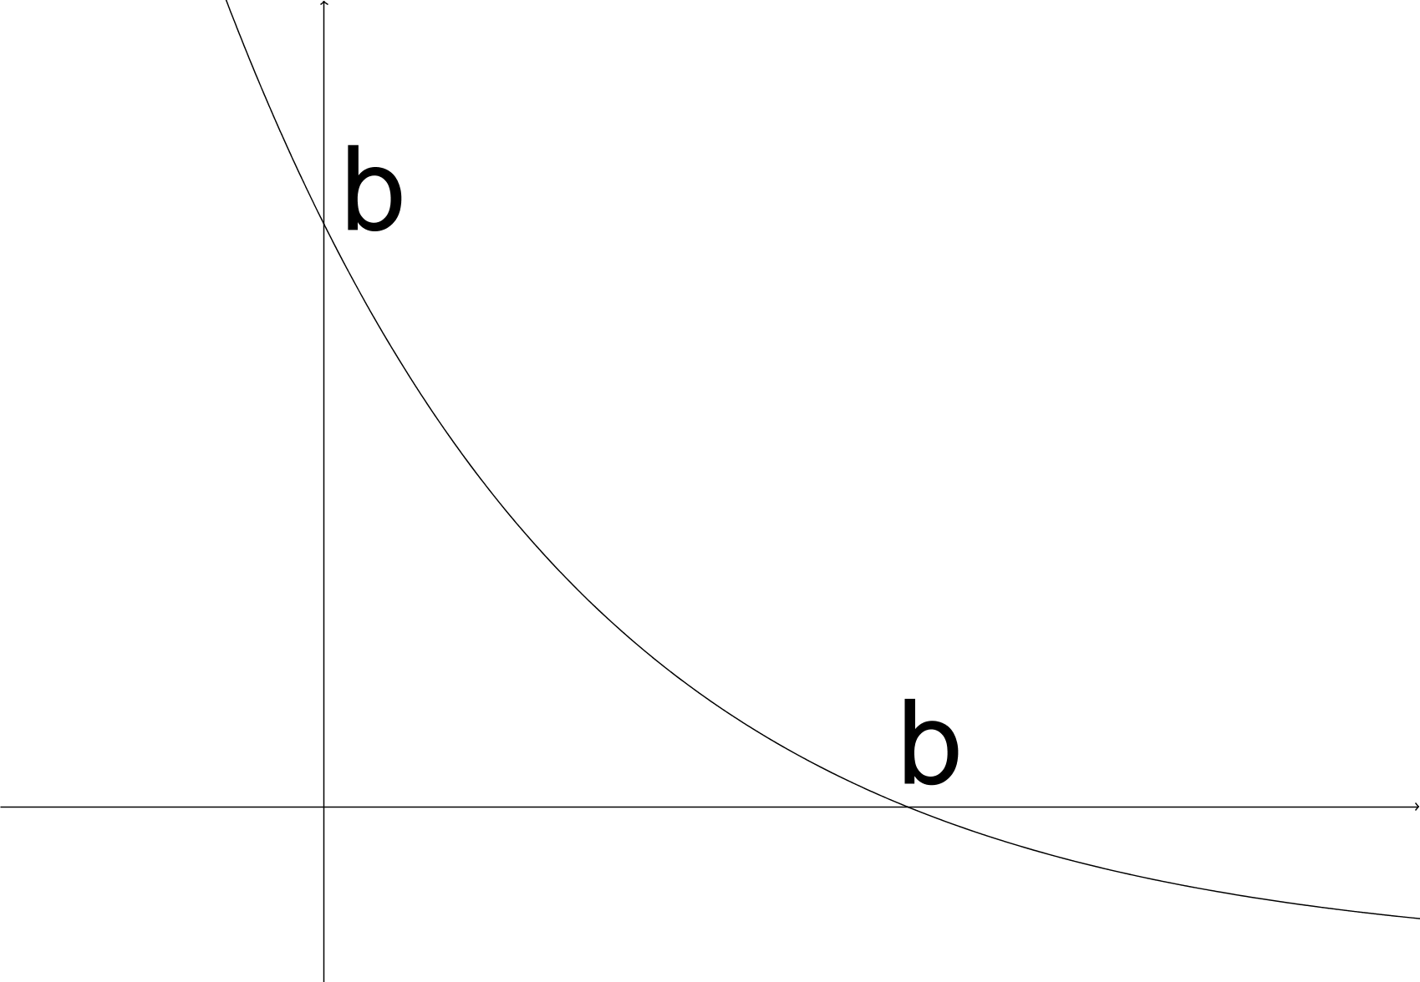
- The graph shows an exponential graph $y=e^{−2x}$ that has been shifted vertically downwards by a units such that the x and y intercepts are now equal.
  - Show that $a=1−b$. (2)
  - Hence, show that $e^{−2b}−1+b=0$ (2)
  - Now use Newton’s method, starting with $b_{0}=0\text{.}5$, to solve for b to 5 decimal places. (5)
[9]
- The graph of $f(x)=\frac{\text{ln}(x)}{x^{2}}$is given below.
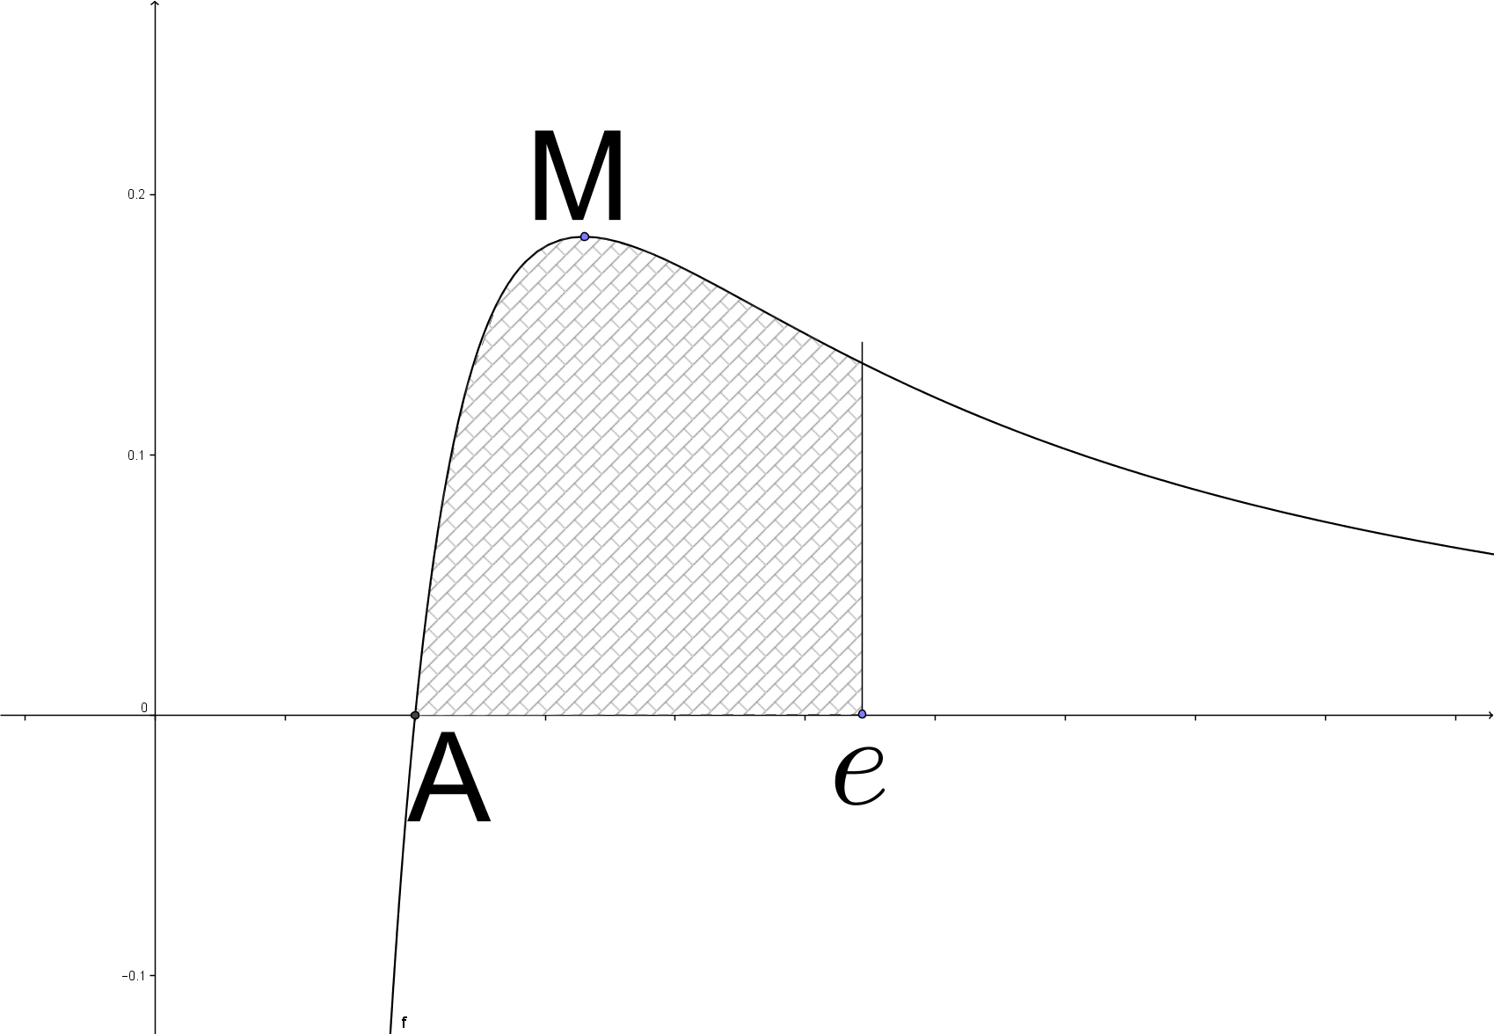
  - Show that the x-int is A(1;0). (2)
  - Determine the coordinates at M, the maximum of f. (5)
  - Use integration by parts, with the fact that $\frac{d}{\text{dx}}\text{ln}(x)=\frac{1}{x}$ , to determine the area of the shaded region. (10)
[17]
- If the graph of$f(x)=\frac{\text{arctan}(x)}{\sqrt{1+x^{2}}}$ from 0 to a is revolved about the x-axis, its volume is $\frac{π^{4}}{\text{192}}$. Solve for a.
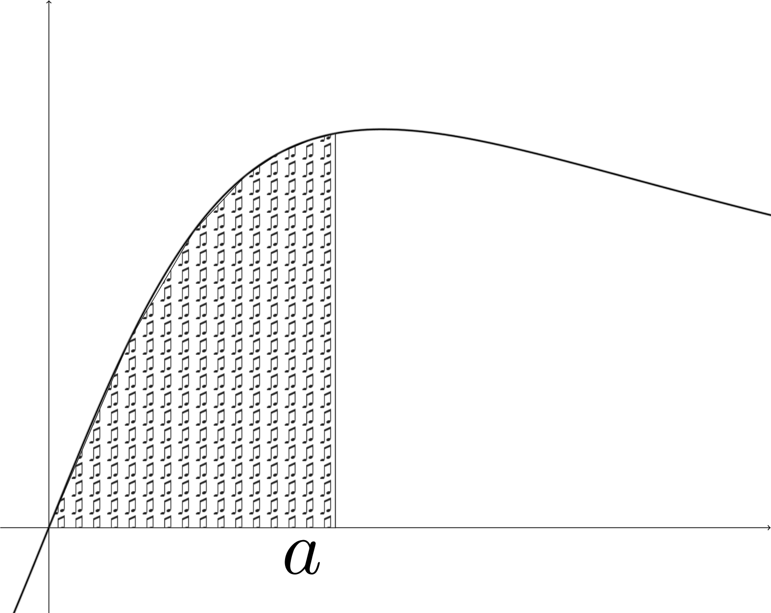
[10]
End of Section A
(208 marks available)

Section B: Statistics (100)

- The people living in 3 houses are classified as children (C), parents (P) or grandparents (G). The numbers living in each house are shown in the table below.
House number 1 | House number 2 | House number 3
4C, 1P, 2G | 2C, 3P, 3G | 1C, 1G

  - All the people in all 3 houses meet for a party. One person at the party is chosen at random. Calculate the probability of choosing a grandparent. (2)
  - A house is chosen at random. Then a person in that house is chosen at random. Using a tree, diagram, calculate the probability that the person chosen is a grandparent. (4)
  - Given that the person chosen by the method in part 1.2 is a grandparent, calculate the probability that there is also a parent living in the house. (4)
[10]

- A box of biscuits contains 30 biscuits, some of which are wrapped in gold foil and some of which are unwrapped. Some of the biscuits are chocolate-covered. 12 biscuits are wrapped in gold foil, and of these biscuits, 7 are chocolate-covered. There are 17 chocolate-covered biscuits in total.
  - Copy and complete the table below to show the number of biscuits in each category. (2)
  - A biscuit is selected at random from the box. Find the probability that the biscuit is wrapped in gold foil. (1)
  - The biscuit is returned to the box. A biscuit is then selected at random from the box. It is an unwrapped biscuit. Find the probability that this biscuit is chocolate-covered. (1)
  - The biscuit is returned to the box. A biscuit is then selected at random from the box. It happens to be chocolate-covered. What is the probability that it was unwrapped. (1)
  - The biscuit is returned to the box. Sarah then takes 4 biscuits without replacement from the box. Find the probability that she takes exactly 2 wrapped biscuits. (4)
[9]

  - In how many ways can a group of 14 people eating at the restaurant be divided between three tables seating 5, 5 and 4? (4)
  - A committee of 5 people is to be chosen from 6 men and 4 women. In how many ways can this be done if:
    - If there must be more men than women on the committee? (5)
    - If there must be 3 men and 2 women, and one particular woman refuses to be on the committee with one particular man. (5)
[14]
- Last year I asked a linear regression question relating the number of ice cream sales on Camps Bay Beach on a particular day to the temperature on that day. Unfortunately I have lost the original table with the relevant data, but managed to find the following results from that data:
$\bar{x}=\text{21}\text{.}8$; $\bar{y}=\text{228}\text{.}3$; $\sum{x}=\text{218}$; $\sum{y}=\text{2283}$; $\sum{x^{2}}=\text{4896}$; $\sum{y^{2}}=\text{634819}$; $\sum{\text{xy}}=\text{53563}$.
Use these results, together with the relevant formula in your formula sheet, to obtain the correct line of least squares for this set of data. [12]
- The times taken to play Beethoven’s Sixth Symphony can be assumed to have a normal distribution with mean 41.1 minutes and standard deviation 3.4 minutes.
  - Find the probability that the symphony will last longer than 42 minutes. (4)
  - If Alice attends five independent occasions on which this symphony is played, what is the probability that the symphony will last less than 42 minutes on at least three of the occasions. (7)
  - The times taken to play Beethoven’s Fifth Symphony can also be assumed to have a normal distribution. The probability that the time is less than 26.5 minutes is 0.1, and the probability that the time is more than 34.6 minutes is 0.05.
Find the mean and standard deviation of the times to play this symphony. (7)
[18]

- Over a long period of time it is found that the time spent at cash withdrawal points follows a normal distribution with mean 2.1 minutes and standard deviation 0.9 minutes. A new system is tried out, to speed up the procedure. The null hypothesis is that the mean time spent is the same under the new system as previously. It is decided to reject the null hypothesis and accept that the new system is quicker if the mean withdrawal time from a random sample of 20 cash withdrawals is less than 1.7 minutes. Assume that, for the new system, the standard deviation is still 0.9 minutes, and the time spent still follows a normal distribution.
  - Calculate the probability of a Type I error, i.e. that we accept that the new system is quicker when it is not (a false positive). (7)
  - If the mean withdrawal time of the new system is actually 1.5 minutes, calculate the probability of a Type II error, i.e. that we do not reject the null hypothesis when we should (a false negative). (7)
[14]
- A polling survey found that a particular party was likely to gain 47% of the votes in an upcoming election. This figure is claimed to be correct to within 1% with 95% confidence. Calculate the minimum number of people that would have had to be surveyed for this claim to have been valid.
You may use the following confidence interval formula, where p is the sample proportion and π is the true proportion:
$P\left(p−z\sqrt{\frac{p(1−p)}{n}}<π<p+z\sqrt{\frac{p(1−p)}{n}}\right)=2H(z)$ [8]
- A certain continuous random variable, X, has the following probability density function (pdf):
$f_{X}(x)=\begin{aligned}\left\{1−\frac{1}{2}x 0≤x≤2 | \right.\end{aligned}$
  - Show that this is a valid pdf. (4)
  - Find $P\left(X>1\text{.}5\right)$. (4)
  - Determine the median of f_{X}. (6)
  - The mean of a continuous random variable with pdf f(x) is:
$μ=\int_{−∞}^{∞}{x⋅f(x)\text{dx}}$
Calculate the mean of this pdf. (4)
[18]
End of Section B (103 marks available)

END OF PAPER!!!
INFORMATION SHEET

General Formulae

$x=\frac{–b±\sqrt{b^{2}–4\text{ac}}}{2a}$

$\sum_{i=1}^{n}{ 1=n}$ $\sum_{i=1}^{n}{i=\frac{n(n+1)}{2}}=\frac{n^{2}}{2}+\frac{n}{2}$

$\sum_{i=1}^{n}{i^{2}=\frac{n\left(n+1\right)\left(2n+1\right)}{6}}=\frac{n^{3}}{3}+\frac{n^{2}}{2}+\frac{n}{6}$

$$\sum_{i=1}^{n}{i^{3}}=\frac{n^{2}{\left(n+1\right)}^{2}}{4}=\frac{n^{4}}{4}+\frac{n^{3}}{2}+\frac{n^{2}}{4}$$

$z=a+\text{bi}$ $z∗a−\text{bi}$

$ℓn A + ℓn B = ℓn \left(\text{AB}\right)$ $ℓn A − ℓn B = ℓn \left(\frac{A}{B}\right)$
$ℓn A^{n} = n ℓn A$ ${\text{log}}_{a} x = \frac{{\text{log}}_{b} x}{{\text{log}}_{b} a}$

Calculus

$\frac{\text{dy}}{\text{dx}}=\frac{\text{dy}}{\text{dt}}×\frac{\text{dt}}{\text{dx}}$

$$\int{f'\left(g(x)\right)}\text{.}g'(x) \text{dx}=f(g(x))+c$$

$$\int{f(x)\text{.}g'(x)\text{dx}}=f(x)\text{.}g(x)−\int{g(x)\text{.}f'(x) \text{dx}}+c$$

$x_{r+1}=x_{r}−\frac{f(x_{r})}{f'(x_{r})}$ $V=π\int_{a}^{b}{y^{2}\text{dx}}$

Function Derivative
$x^{n}$ ${\text{nx}}^{n−1}$
$\text{sin}x$ $\text{cos}x$
$\text{cos}x$ $−\text{sin}x$
$\text{tan}x$ ${\text{sec}}^{2}x$
$\text{cot}x$ $−{\text{cosec}}^{2}x$
$\text{sec}x$ $\text{sec}x\text{.}\text{tan}x$
$\text{cosec} x$ $−\text{cosec} x\text{.}\text{cot}x$
$\text{arcsin} x$ $\frac{1}{\sqrt{1−x^{2}}}$
$\text{arctan} x$ $\frac{1}{1+x^{2}}$
$f(g(x))$ $f'(g(x))\text{.}g'(x)$
$f(x)\text{.}g(x)$ $g(x)\text{.}f'(x)+f(x)\text{.}g'(x)$
$\frac{f(x)}{g(x)}$ $\frac{g(x)\text{.}f'(x)−f(x)\text{.}g'(x)}{{\left[g(x)\right]}^{2}}$

Trigonometry

$s=rθ$

In ABC: $\frac{a}{\text{sin}A}=\frac{b}{\text{sin}B}=\frac{c}{\text{sin}C}$

$$a^{2}=b^{2}+c^{2}–2\text{bc}\text{.}\text{cos}A$$

${\text{sin}}^{2}A+{\text{cos}}^{2}A=1$ $1+{\text{tan}}^{2}A={\text{sec}}^{2}A$ $1+{\text{cot}}^{2}A={\text{cosec}}^{2}A$

$\text{sin}\left(A±B\right)=\text{sin}A\text{.}\text{cos}B±\text{cos}A\text{sin}B$ $\text{cos}\left(A±B\right)=\text{cos}A\text{cos}B∓\text{sin}A\text{sin}B$

$\text{sin}2A=2\text{sin}A\text{cos}A$ $\text{cos}2A={\text{cos}}^{2}A−{\text{sin}}^{2}A$

$$\text{sin}A\text{.}\text{cos}B=\frac{1}{2}\left[\text{sin}(A+B)+\text{sin}(A−B)\right]$$

$$\text{sin}A\text{.}\text{sin}B=\frac{1}{2}\left[\text{cos}(A−B)−\text{cos}(A+B)\right]$$

$$\text{cos}A\text{.}\text{cos}B=\frac{1}{2}\left[\text{cos}(A−B)+\text{cos}(A+B)\right]$$
Matrix Transformations

Finance & Modelling

$$P_{n+1}=P_{n}+{\text{rP}}_{n}\left(1−\frac{P_{n}}{K}\right)$$

$R_{n+1}=R_{n}+{\text{aR}}_{n}\left(1−\frac{R_{n}}{K}\right)−{\text{bR}}_{n}F_{n}$ $F_{n+1}=F_{n}+f\text{.}{\text{bR}}_{n}F_{n}−{\text{cF}}_{n}$

Statistics

$P(A)=\frac{n(A)}{n(s)}$

$$P(A\text{or}B)=P(A)+P(B)–P(A\text{and}B)$$

$Z=\frac{X−μ}{σ}$ $z=\frac{x−μ}{\frac{σ}{\sqrt{n}}}$

$Z=\frac{\bar{x}−\bar{y}}{\sqrt{\frac{σ_{x}^{2}}{n_{x}}+\frac{σ_{y}^{2}}{n_{y}}}}$ $b=\frac{n\sum{(\text{xy})−\sum{x\sum{y}}}}{n(\sum{x^{2})−(\sum{x)^{2}}}}$

NORMAL DISTRIBUTION TABLE

Areas under the Normal Curve
$\frac{1}{\sqrt{2π}} \int{ e ^{− ½ x ^{2}}} \text{dx}$
H(z) =

H(-z) = H(z), H(∞) = ½

Entries in the table are values of H(z) for z ≥ 0.
z | ,00 | ,01 | ,02 | ,03 | ,04 | ,05 | ,06 | ,07 | ,08 | ,09
0  0,1  0,2  0,3  0,4  0,5  0,6  0,7  0,8  0,9  1,0  1,1  1,2  1,3  1,4  1,5  1,6  1,7  1,8  1,9  2,0  2,1  2,2  2,3  2,4  2,5  2,6  2,7  2,8  2,9  3,0  3,1  3,2  3,3  3,4  3,5  3,6  3,7  3,8  3,9  4,0 | ,0000  ,0398  ,0793  ,1179  ,1554  ,1915  ,2257  ,2580  ,2881  ,3159  ,3413  ,3643  ,3849  ,4032  ,4192  ,4332  ,4452  ,4554  ,4641  ,4713  ,4772  ,4821  ,4861  ,48928  ,49180  ,49379  ,49534  ,49653  ,49744  ,49813  ,49865  ,49903  ,49931  ,49952  ,49966  ,49977  ,49984  ,49989  ,49993  ,49995  ,49997 | ,0040  ,0438  ,0832  ,1217  ,1591  ,1950  ,2291  ,2611  ,2910  ,3186  ,3438  ,3665  ,3869  ,4049  ,4207  ,4345  ,4463  ,4564  ,4649  ,4719  ,4778  ,4826  ,4864  ,48956  ,49202  ,49396  ,49547  ,49664  ,49752  ,49819  ,49869  ,49906  ,49934  ,49953  ,49968 | ,0080  ,0478  ,0871  ,1255  ,1628  ,1985  ,2324  ,2642  ,2939  ,3212  ,3461  ,3686  ,3888  ,4066  ,4222  ,4357  ,4474  ,4573  ,4656  ,4726  ,4783  ,4830  ,4868  ,48983  ,49224  ,49413  ,49560  ,49674  ,49760  ,49825  ,49874  ,49910  ,49936  ,49955  ,49969 | ,0120  ,0517  ,0910  ,1293  ,1664  ,2019  ,2357  ,2673  ,2967  ,3238  ,3485  ,3708  ,3907  ,4082  ,4236  ,4370  ,4484  ,4582  ,4664  ,4732  ,4788  ,4834  ,4871  ,49010  ,49245  ,49430  ,49573  ,49683  ,49767  ,49831  ,49878  ,49913  ,49938  ,49957  ,49970 | ,0160  ,0557  ,0948  ,1331  ,1700  ,2054  ,2389  ,2704  ,2995  ,3264  ,3508  ,3729  ,3925  ,4099  ,4251  ,4382  ,4495  ,4591  ,4671  ,4738  ,4793  ,4838  ,4875  ,49036  ,49266  ,49446  ,49585  ,49693  ,49774  ,49836  ,49882  ,49916  ,49940  ,49958  ,49971 | ,0199  ,0596  ,0987  ,1368  ,1736  ,2088  ,2422  ,2734  ,3023  ,3289  ,3531  ,3749  ,3944  ,4115  ,4265  ,4394  ,4505  ,4599  ,4678  ,4744  ,4798  ,4842  ,4878  ,49061  ,49286  ,49461  ,49598  ,49702  ,49781  ,49841  ,49886  ,49918  ,49942  ,49960  ,49972 | ,0239  ,0636  ,1026  ,1406  ,1772  ,2123  ,2454  ,2764  ,3051  ,3315  ,3554  ,3770  ,3962  ,4131  ,4279  ,4406  ,4515  ,4608  ,4686  ,4750  ,4803  ,4846  ,4881  ,49086  ,49305  ,49477  ,49609  ,49711  ,49788  ,49846  ,49889  ,49921  ,49944  ,49961  ,49973 | ,0279  ,0675  ,1064  ,1443  ,1808  ,2157  ,2486  ,2794  ,3078  ,3340  ,3577  ,3790  ,3980  ,4147  ,4292  ,4418  ,4525  ,4616  ,4693  ,4756  ,4808  ,4850  ,4884  ,49111  ,49324  ,49492  ,49621  ,49720  ,49795  ,49851  ,49893  ,49924  ,49946  ,49962  ,49974 | ,0319  ,0714  ,1103  ,1480  ,1844  ,2190  ,2517  ,2823  ,3106  ,3365  ,3599  ,3810  ,3997  ,4162  ,4306  ,4429  ,4535  ,4625  ,4699  ,4761  ,4812  ,4854  ,4887  ,49134  ,49343  ,49506  ,49632  ,49728  ,49801  ,49856  ,49896  ,49926  ,49948  ,49964  ,49975 | ,0359  ,0753  ,1141  ,1517  ,1879  ,2224  ,2549  ,2852  ,3133  ,3389  ,3621  ,3830  ,4015  ,4177  ,4319  ,4441  ,4545  ,4633  ,4706  ,4767  ,4817  ,4857  ,4890  ,49158  ,49361  ,49520  ,49643  ,49736  ,49807  ,49861  ,49900  ,49929  ,49950  ,49965  ,49976

